Cribbage rules
Hand rules
15 = 2 points
Straight = point per card (min three)
Pairs = 2 points
Triple = 6 points
Quad = 12 points
Nob = 1

Pegging rules
Total of 15-2points
Pair-2points
Triple = 6 points
Quad = 12 points
Total 31-2 points
Last card-1 point (unless 31)
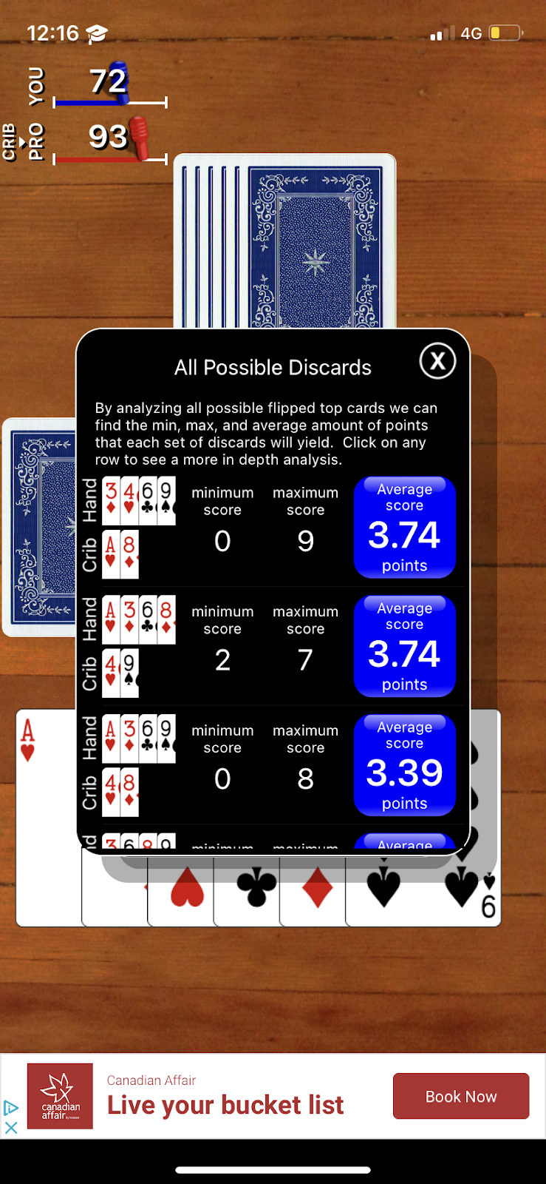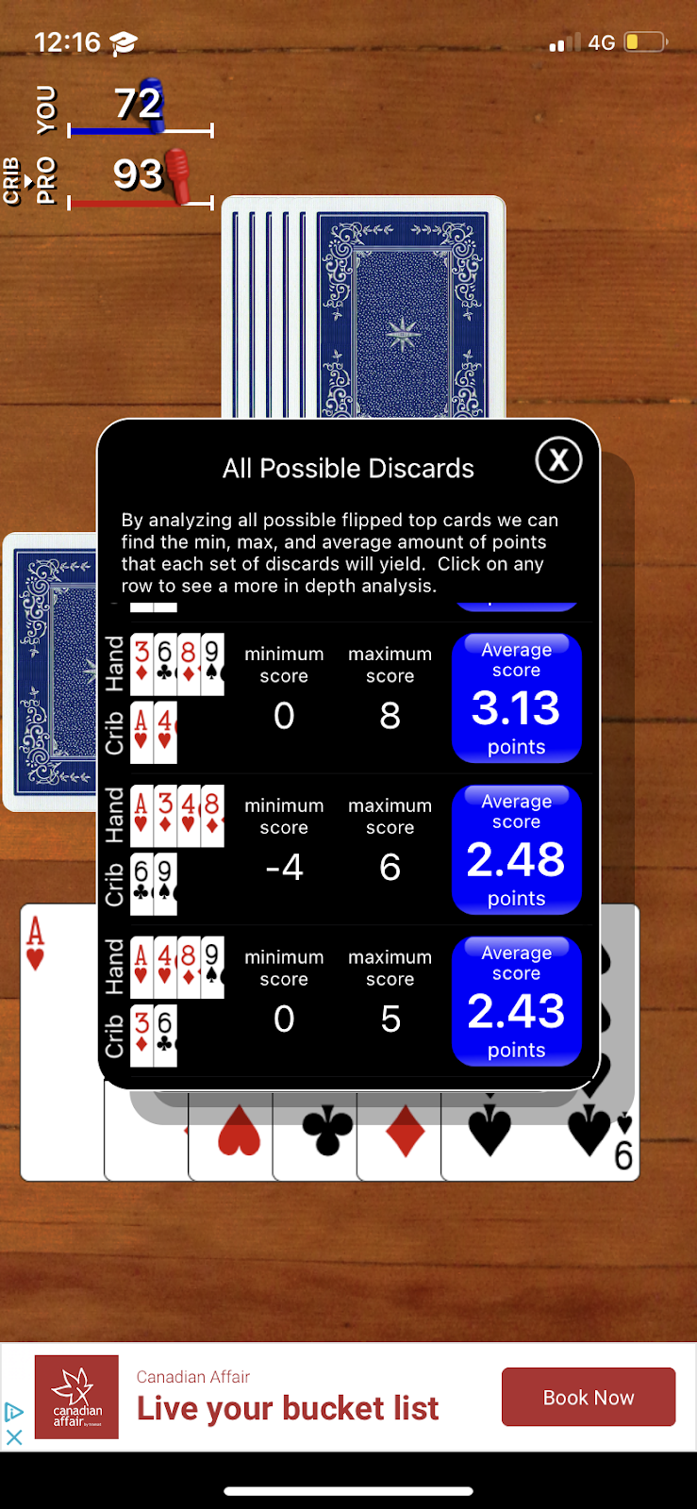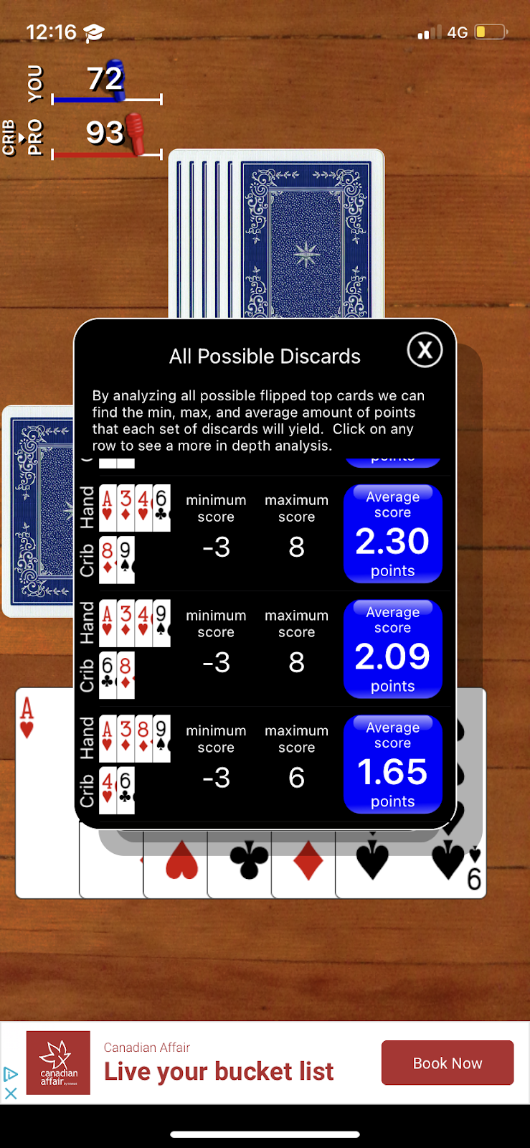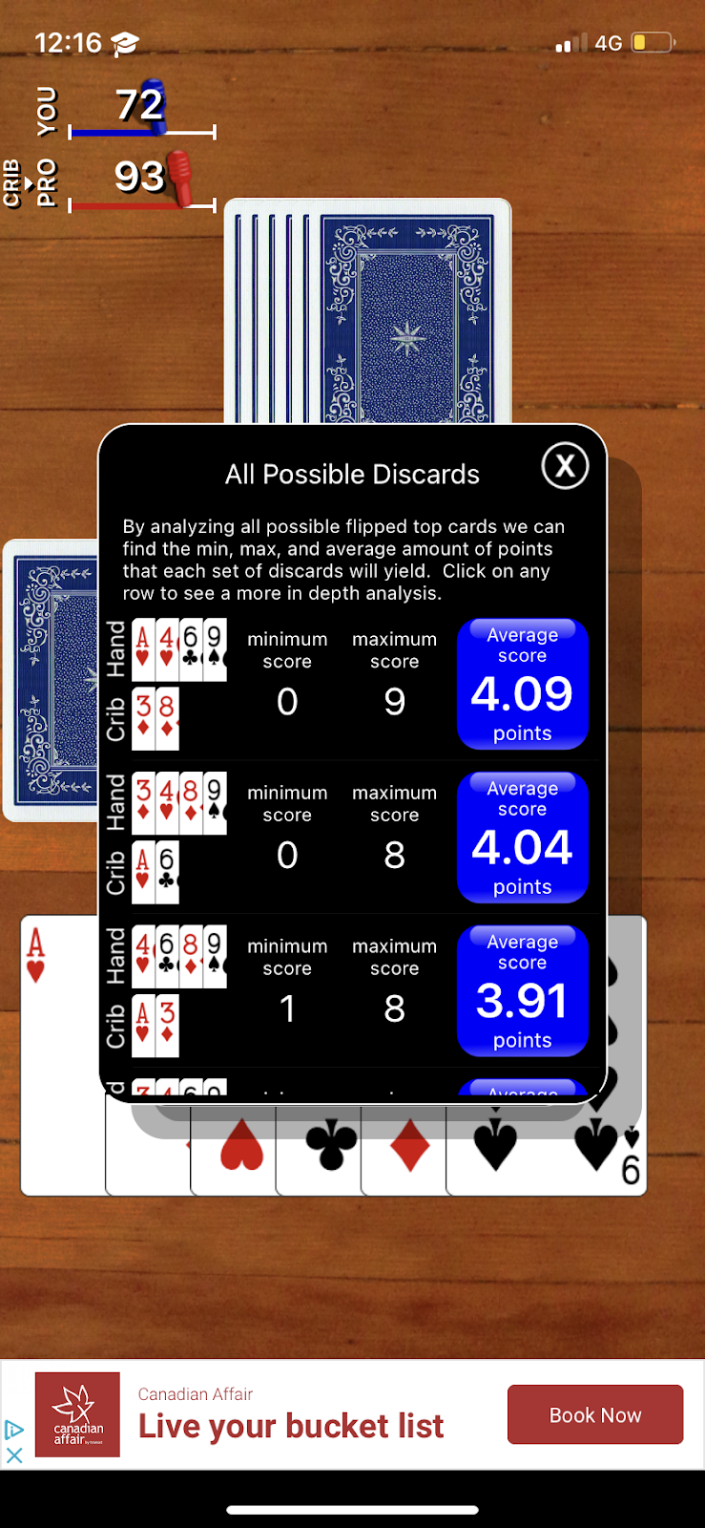

Optimal card
Random
10s
Crib incr/decr

